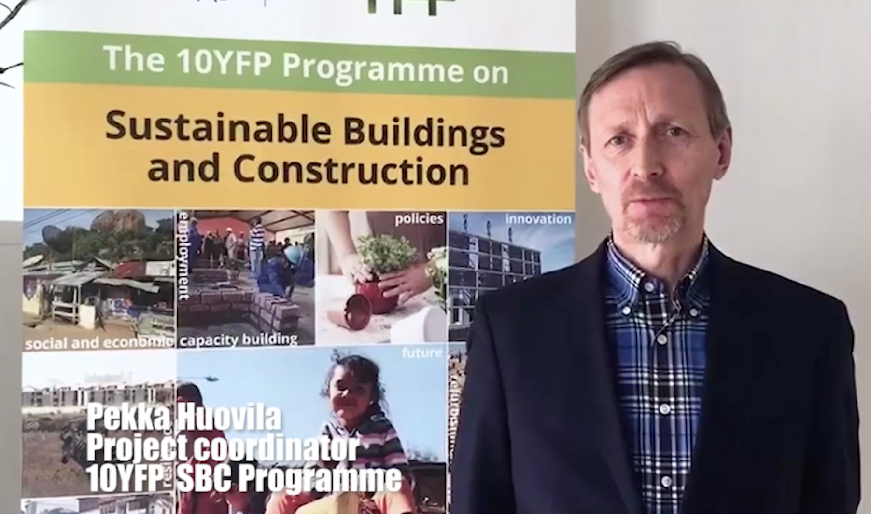

SBC Update in South-South Meeting in Brasilia

