Activity title - School / college program for production and consumption education
What do educational institutions produce and how do we measure the output? These questions are fundamental and pose serious challenges to capturing education output correctly. Traditionally, education services are mostly produced by government and nonprofit institutions. We recommends education services provided by government entities and nonprofit institutions serving households at “economically not significant prices” to be valued by the cost of production, i.e., the sum of intermediate consumption, compensation of employees, consumption of fixed capital and taxes on production. Most statistical agencies in the world follow this tradition.
Who let the implementation of this?
Dr. Ramanjaneyulu G.V,
Karthik Teja Pulugurtha,
Madhusudhan Reddy Panyala,
Nambur Kumar.
Who did you collaborate with?
We collaborated with 3 schools.
1) Government Nehru Memorial High School, Malakpet
2) Excellencia Infinitum School, Shamirpet.
3) Pebble Creek Life School
There is scope to add three more schools to the program.
We are also working with Teach for India (TFI) which is a non-profit organization that is a part of the Teach for All network. The Fellowship recruits college graduates and working professionals to serve as full-time teachers in low-income schools for two years. Teach for India fellows offer an excellent opportunity to expand our reach across 100 plus schools. Training the fellows to institute a school garden program and offering them assistance in implementation is the next step for the project.
We are currently collaborating with 2 colleges.
1) Tata Institute of social Sciences Hyderabad
2) St. Pious Degree college

Objectives:
School garden programs are multi-intervention packages incorporating agriculture, nutrition and WASH (water, sanitation and hygiene) education, and community outreach to improve community food security and nutrition. Good nutrition relies on healthy food systems, access to health services, and clean environments. A school garden can be regarded as a small food system; a healthy garden can include the production of plant and animal food and be designed to address biodiversity, healthy diets and eco-friendly environments. These gardens can be used as platforms for environmental education, nutrition behaviour change communication, and to promote community engagement.
School Garden Programs: Four Essential Components to Achieve Food and Nutrition Goals
To successfully achieve food and nutrition goals, our multi-intervention school garden program has the following elements:
• A curriculum integrating agriculture, nutrition and WASH concepts and practices
• A school garden for hands-on learning
• Involvement of parents and the wider community for support and promotion
The program uses the school garden as an entry point for children to learn about food systems, including how food is produced and reaches consumers, and how it can benefit their own health as well as the health of their families and the environment. The school garden program is a hands-on learning tool that integrates agriculture, nutrition and WASH education and practices and promotes inter-generational learning and community outreach. Learning-by-doing transforms knowledge into practices. Good agricultural, food, nutrition and WASH practices at the individual and household levels are the key elements to achieve food security and nutrition.
1. Agriculture, Nutrition and WASH Education
A school garden program is an educational tool to teach students about agriculture, nutrition and health, and to equip them with the critical and holistic thinking to face challenges as environments change. Education contributes to breaking the vicious cycle of poverty and malnutrition and brings positive social change. Educating children determines the nutrition of the next generation. Parental education, especially maternal education, is directly associated with decreased child malnutrition, increased wealth, and better schooling choices for their children. Agricultural and environmental education positively increases students’ knowledge, understanding, and appreciation of the environment and food production system. It provides them with the ability to grow their own food for nutrition and equips them for a possible career in agriculture. Nutrition education positively influences children’s dietary behaviour. Nutrition knowledge is significantly linked to healthy eating, including fruit and vegetable consumption. Paired with school gardening, nutrition education significantly increased students’ consumption of fruit and vegetables, and vitamin A, C and fiber intake. Water, sanitation and hygiene (WASH) is a necessary component of a school garden program to reduce life-threatening illnesses due to unsanitary practices and environments. These illnesses hinder absorption of nutrients, undermining nutrition efforts, and can cause stunting and anemia in children. WASH interventions, including hand washing with soap, improved water quality, and disposal of fecal matter, significantly reduce the risk of diarrhoea. For instance, reducing open defecation is associated with increased child height.

2. School Gardens for Hands-On Learning and Stimulating Behaviour Change
The school garden is an educational tool for students to practice knowledge and skills learned in the classroom. Through hands-on activities, school garden programs stimulate learning and behavioural change. School gardens with nutrition education implemented and vigorously tested in many schools in the US and Europe significantly improved students:
• Fruit and vegetable knowledge and awareness
• Attitudes, preferences, and willingness to eat diverse foods
• Fruit and vegetable intake
• Healthy dietary habits
• Physical activity levels
• Academic performance
• Appreciation and care for the environment
• Sense of responsibility, confidence, enhanced communication and well-being
3. School Gardens as Part of a Food System
A school garden is a small food system engaged in the processes of food production, distribution and consumption. Food systems influence the quantity, quality and affordability of food, thus leading to outcomes in nutrition, health and quality of life. A school garden produces fruit and vegetables, which can be consumed by students through school meals, or by the family when fresh produce is distributed to students to bring home. School feeding programs are found to increase school attendance by 4-6 days annually and lead to weight gain in students. School feeding can benefit local agricultural development if food is procured from smallholder farmers in the community. Meals and garden produce shared with the students also increases household food consumption and nutrition. Food marketing exists in the school garden program through nutrition promotions and campaigns to both students and the community. Nutrition promotions using different media can significantly improve dietary habits and increase consumption of healthy foods.
4. School Gardens as an Entry Point for Household and Community
Nutrition Sensitive Interventions The school is a place of learning and a central part of the community, where there are regular interactions between students, parents, teachers, and community members. The school can be used as a platform to deliver school and community interventions aimed at improving nutrition and health outcomes. Through community outreach, teachers and students can use the garden as a demonstration site for agricultural techniques and delivering nutrition messages to parents and the wider community.
Nutrition and health messages and campaigns can effectively promote healthy eating and lifestyle habits, food choices School garden programs that promote home gardening by giving seed to students to grow at home have seen an increase in the number of home and community gardens for home and commercial production in the neighbourhood. For lower income areas where food security is a main concern, school garden programs must link to home gardening in the community to increase the local availability of healthy food. Evidence from Asia, Africa and Latin America suggests that home gardens can play a role in increased diet diversity and micronutrient intakes with benefits in family income and employment, and ecosystem services. Vegetables are easy to grow and provide essential micronutrients and health-promoting phytonutrients to alleviate malnutrition in the household. However, home garden programs require investment in agricultural training and nutrition education to achieve nutritional outcomes.
Narrative report – Goals of the activity
Accomplishments and future expected achievements
Accomplishments:
1) Created a curriculum to teach sustainable consumption and production practices.

2) Successfully trained about 300 students in SCP module

3) Successfully created a piratical lab/school garden for learning sustainable food production which includes
a) Reusing material for food production
b) Soil management & Sowing Techniques
c) Organic Pest Management techniques
d) Organic fertilizer production Techniques
e) Building nutrient recycling/composting modules

4) Imparted skills within student to grow food

Expected Achievements:

1) Creating a Herbarium for the Student

2) Arranging more student field visits

3) Enhancing the program

Glimpse:
Malakpet school kitchen garden set up:
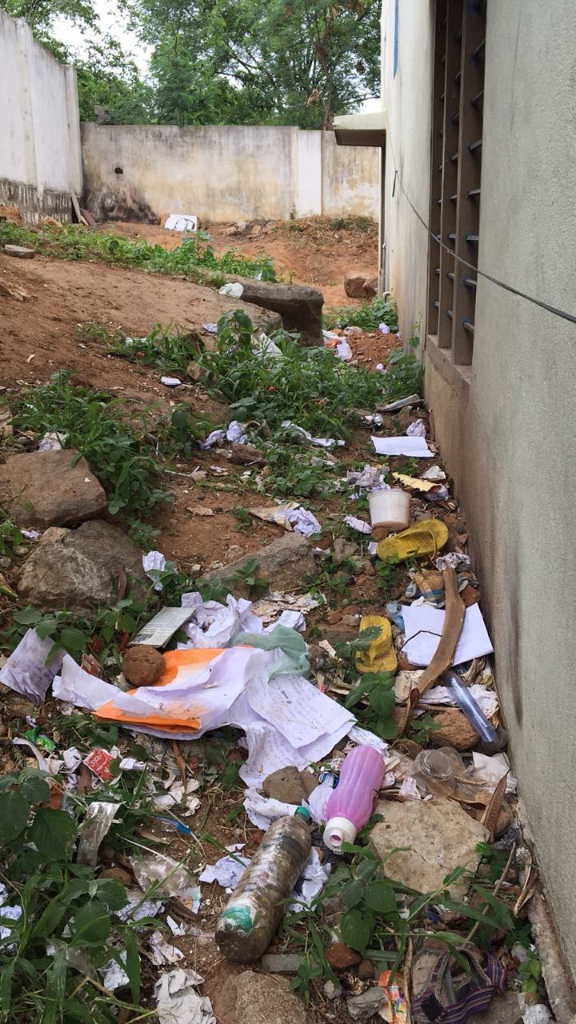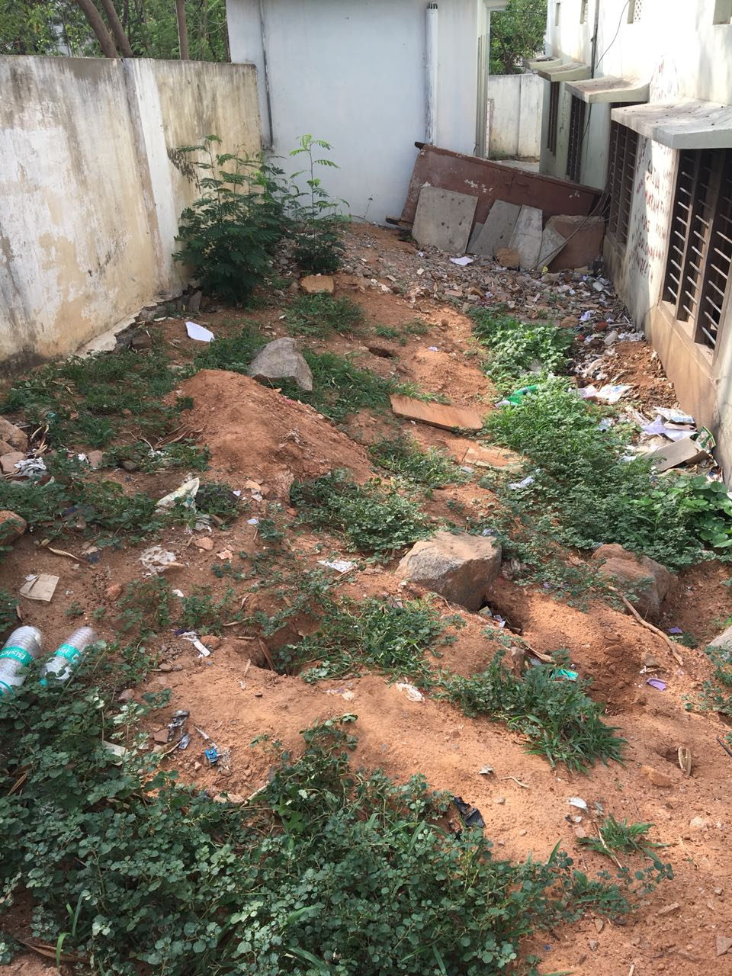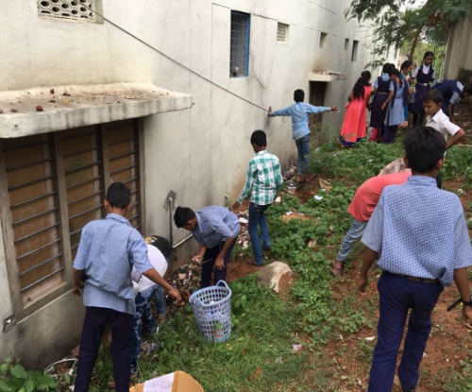
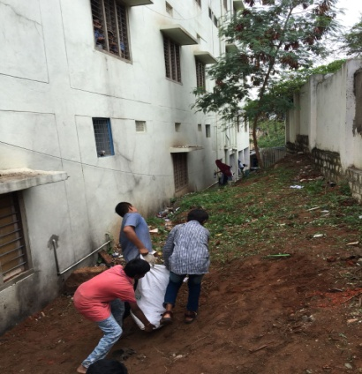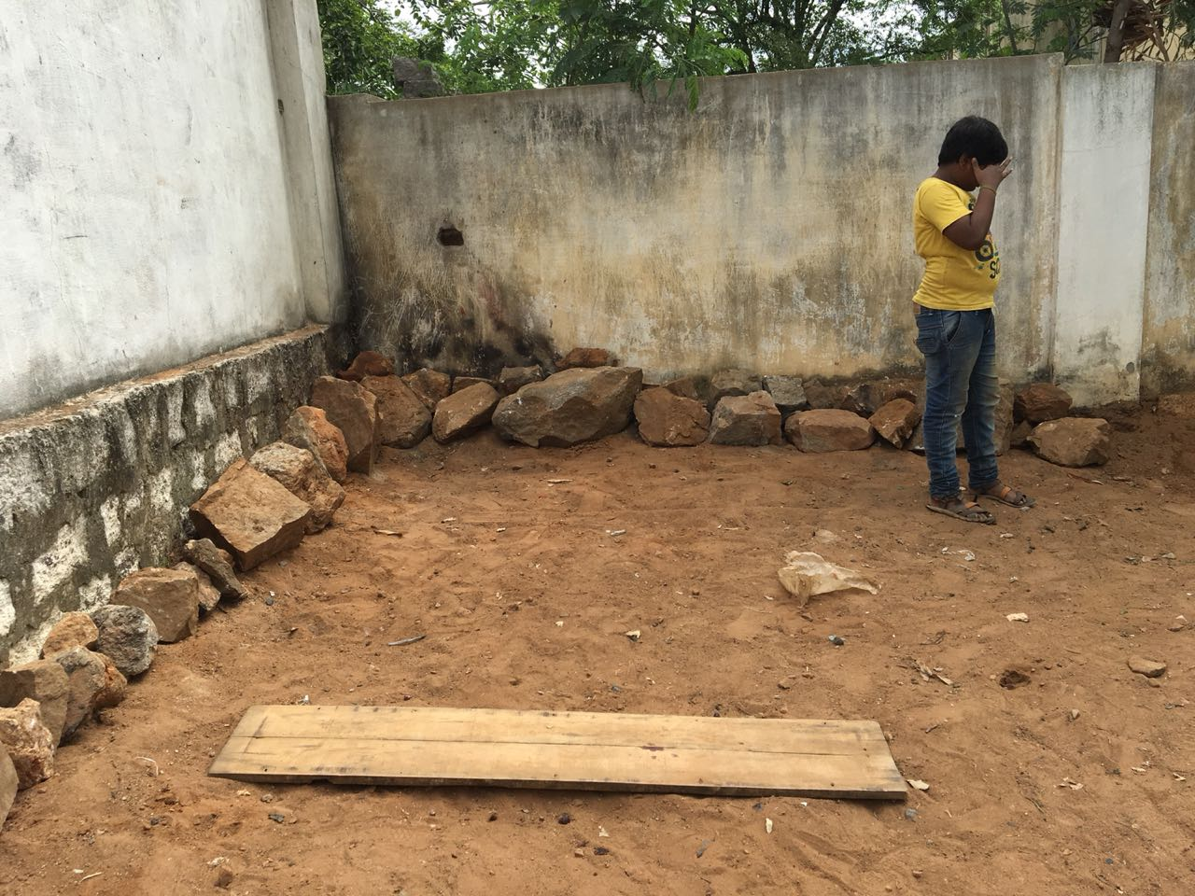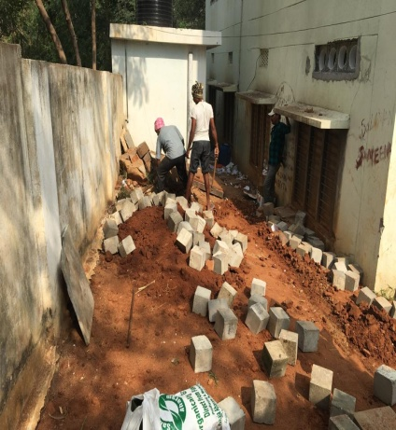

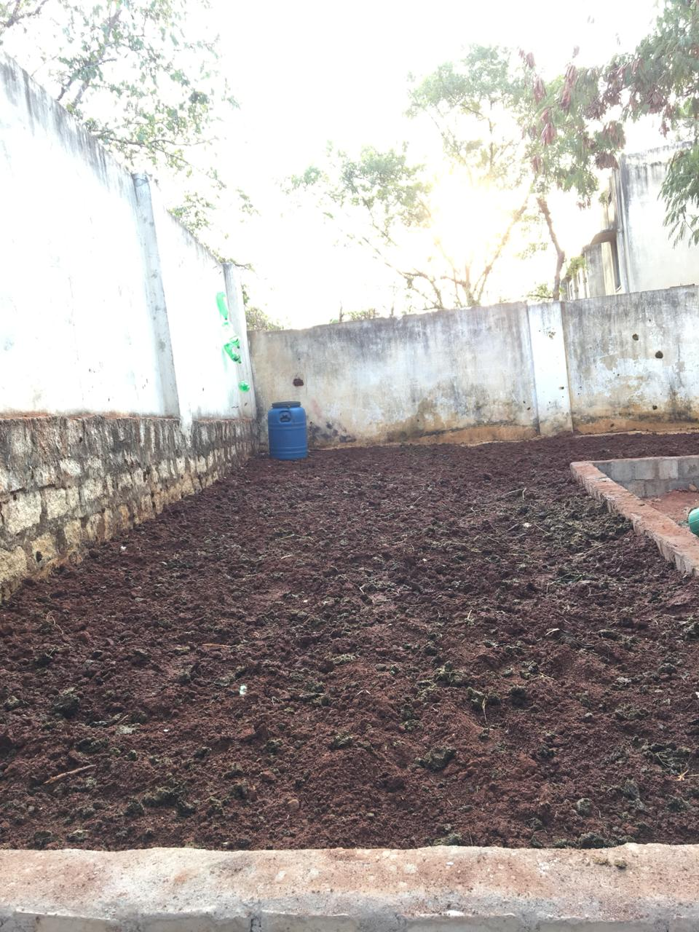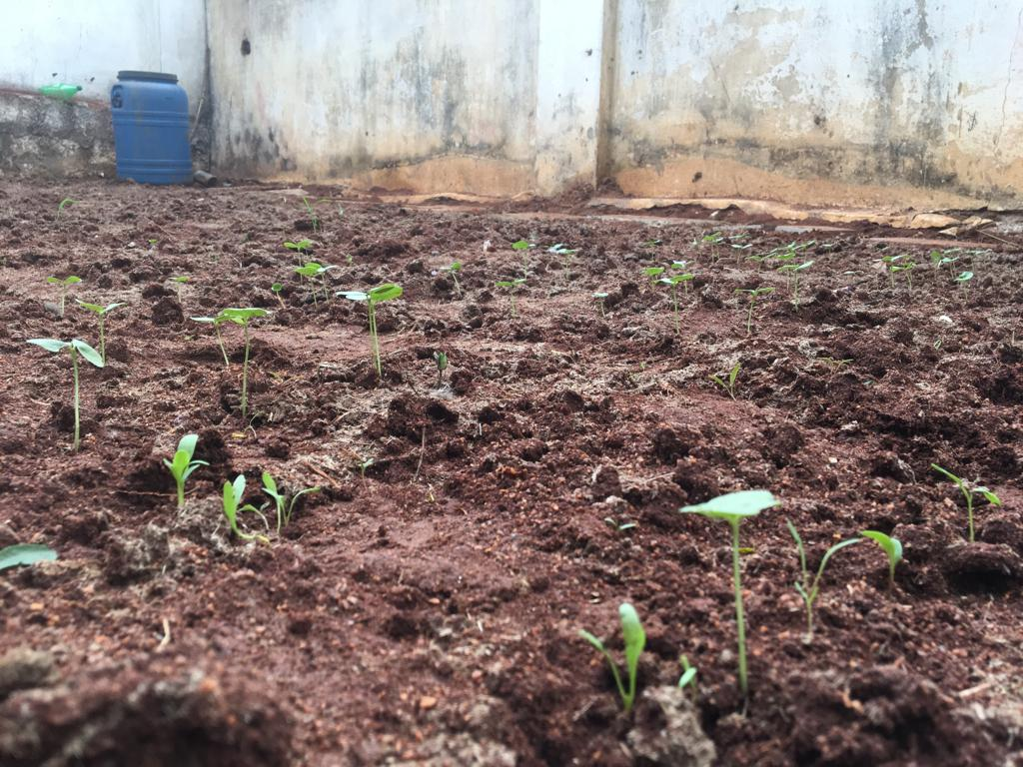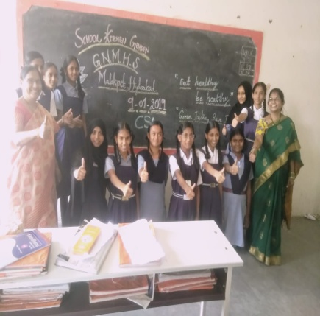

Excelencia Infinitum School, Shamirpet
